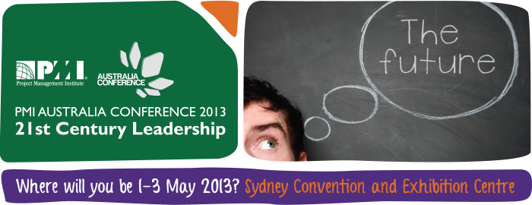

“How many PMs will be retrenched this year?“. Would belonging to a professional organisation or attending the 2013 PMI Australia Conference make any difference?”
By Julia Checchia, Immediate Past President, PMI Sydney Chapter

This year, as the past president of the PMI Sydney Chapter board, I no longer need to be in the front foot of strategy and operations for the chapter. Instead, I have been dedicating time to understanding how to better promote the art, science and benefit of project management in Australia and New Zealand. With that in mind, I have been paying a lot more attention to social media and what members, practitioners and experts are posting on LinkedIn, Twitter, Facebook and others.

As I was “social media dreaming”, I came across a LinkedIn post regarding” How many Project Managers will be retrenched this year ?”. After reading the comments, I thought people may not realise how useful it is to belong to a professional organisation in times such as this. An active member of a professional organisation can truly turn their “fate” and create their own “luck”. You may be thinking, why would I say that? Well here is what PMI, as a professional organisation, offers to members and practitioners:

- Partnership with proactive and forward-thinking recruitment organisations, such as Paxus, to offer our members opportunities to improve their professional representation; social media profile in order to maximise our members position in the job market.

- Links with innovative Registered Education Providers who are committed to provide high quality training at competitive rates so our members can improve their professional capabilities.
- The Sydney chapter holds a variety of events where Subject Matter Experts present up-to-date topics, providing opportunities for a professional growth and networking.
- PMI created the Project Management Body of Knowledge and other related professional standards. Professionals from all over the world contribute to its improvement and currency, providing opportunities for our members to influence the future of project management.
- Strong bonds with Universities, VETs and Colleges enable an environment of trust and mentorship to the future professionals in project management. This helps to bridge the gap and community challenges that the profession faces in the 21st century. With many current leaders at retiring age, the new leaders need to find ways to retain the knowledge that may be lost if we do not have a plan to bridge that gap before it is too late.
- We keep an active association with the International Institute of Business Analysis (IIBA) and Change Management Institute (CMI). Through the integration of our three professions, we help our members be more effective in ensuring project success.
- Our members can also contribute to the profession through study groups, project management advocacy in schools, assessment and coaching in project management capabilities in the not-for-profit sector. All these help to create the foundation to build a better future.

If you have not had a chance to come to an event, a professional development course, a networking session or a mentoring session for a while, you have the opportunity to immerse yourself in project management during the 2013 PMI Australia Conference happening on 1-3 May 2013 at the Sydney Convention and Exhibition Centre at Darling Harbour, Sydney, Australia..

This is the first ever conference led and delivered by the collaboration of the PMI Australian chapters. This conference is being delivered by Australians to Australians and by practitioners to practitioners.

This conference is the result of hard working volunteers from all over Australia who believe and strive to make the impossible possible. Join us and create “your own luck”.

Register here http://www.pmi.org.au/register-here/ or for more information on the conference, simply visit http://www.pmi.org.au/

